RFM Customer Retention Strategy

- Project Overview
A UK-based online retailer sells household and office products across the United Kingdom. Over Dec 2010 – Dec 2011, management observed declining repeat purchase rates and wanted to move from a one-size-fits-all marketing approach to segmented, data-driven retention strategies.

Business questions:
1. Which customer segments drive the most revenue?
2. Which segments carry the highest churn risk (90+ days without a purchase)?

Using RFM (Recency, Frequency, Monetary) quintile scoring, 4,338 customers were segmented into seven behavioural groups. The output is a tiered retention strategy that directs marketing resources to the highest-impact segments first.

- Dataset Summary
- Source: https://archive.ics.uci.edu/dataset/352/online+retail
- Rows: 541,909
- Columns: 8
- Period: Dec 2010 - Dec 2011
- Key Features:
  - Transaction details (InvoiceNo, StockCode, Quantity, UnitPrice)
  - Customer info (CustomerID, Country)
  - Product info (Description)
  - Temporal (InvoiceDate)
  - Missing Data: 135,080 values in CustomerID column

- Exploratory Data Analysis using Python
Data preparation and cleaning were performed in Python:
- Data Loading: Imported the dataset using pandas.
- Column Standardization: Renamed columns to snake case for better readability and documentation.
- Initial Exploration: Used df.info() to check structure and .describe() for summary statistics.
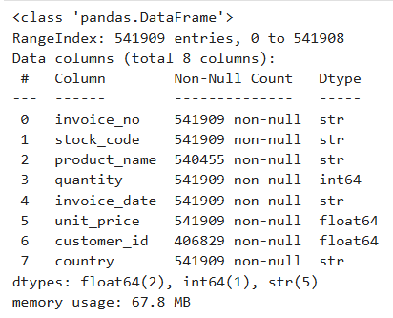

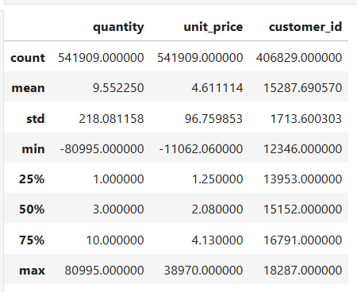

- Data Cleaning

- Date Parsing: Converted invoice_date to datetime with dayfirst=True
- Removed Cancellations: Filtered out all invoices where invoice_no starts with ‘C’
- Removed Missing Customers: Dropped rows where customer_id is null
- Removed Invalid Prices: Filtered rows where unit_price <= 0
- Removed Invalid Quantities: Filtered rows were quantity <= 0
- Created Revenue Column: revenue = quantity * unit_price
- Reference Date: Set to 2011-12-09 (latest transaction in the dataset)
Final cleaned shape: 397884 rows * 9 columns
- RFM Scoring & Segmentation
- Aggregation: Grouped by customer_id to compute Recency, Frequency and Monetary per customer.
- Scoring: Applied pd.qcut() with 5 bins (quintiles) after rank(method=’first’) to handle ties.
- Segmentation: Assigned 7 named segments via a rule-based decision tree on RFM scores.
- Churn Flag: churned = 1 if recency ≥ 90 days.
Churn threshold justification: A 90-day inactivity threshold was chosen based on the dataset’s median inter-purchase interval (~45 days) - customers inactive for 2x the median gap are considered churned.

Segmentation hierarchy:
- Recency → splits ACTIVE (R≥3) vs LAPSED (R≤2)
- Frequency → ranks loyalty within each tier
- Monetary → separates high-value from low-value
Segment | Customers | Criteria | Business Meaning
Champions | 947 | R≥4, F≥4, M≥4 | Recent, frequent, high-spend. Protect all costs.
Loyal Customers | 454 | R≥3, F≥4, M≥3 | Recent, very frequent, solid spend. Reliable revenue.
Potential Loyalists | 190 | R≥4, F=3, M≥3 | Recent, moderate frequency, good spend. Nudge toward loyalty.
Can’t Lose Them | 173 | R≤2, F≥4, M≥4 | Lapsed, but was high-value & frequent. Highest urgency.
At Risk | 207 | R=2, F≥3, M≥3 | Recently lapsed, was a decent buyer. Recoverable window.
Hibernating | 106 | R≤2, M≥4 | Lapsed, low frequency, but high per-transaction value. Low-cost nudge.
Low Priority | 2,261 | All remaining | Insufficient value or engagement for active intervention.

- Data Analysis using SQL (Business Transactions)
Structured analysis was performed in PostgreSQL to answer key business questions:
- Revenue by Segment – Identified the revenue contribution of each customer segment.

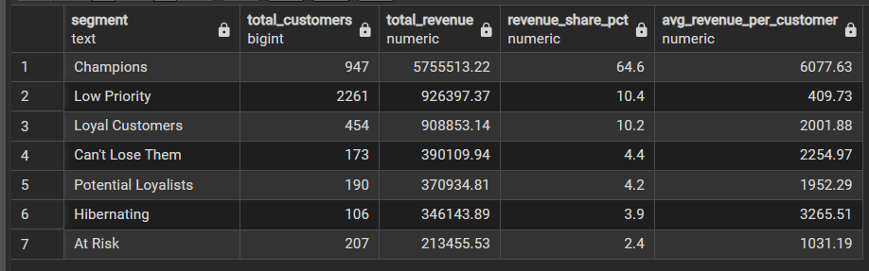

- Customer Distribution– Showed the proportion of customers in each segment.

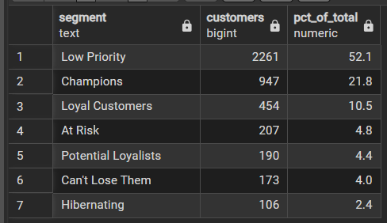

- Churn Rate & Revenue at Risk – Measured the percentage of churned customers and the monetary value at risk per segment.

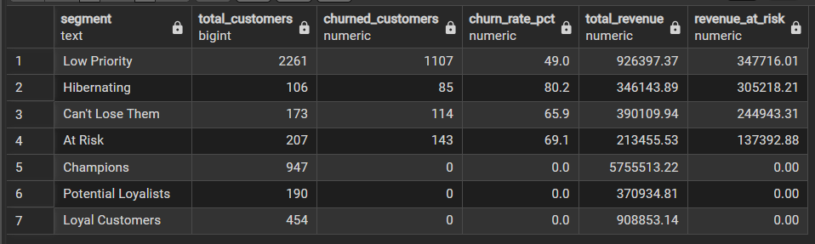
- Top 10 High-Value At-Risk Customers – Identified the 10 churned customers with the highest historical spend (90th percentile threshold) to prioritise for win-back outreach.

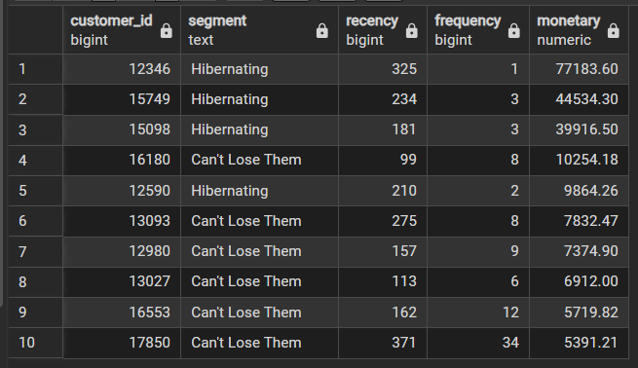

- Top 3 Products by Revenue per Segment – Identified cross-sell opportunities for Loyal Customers and Champions.

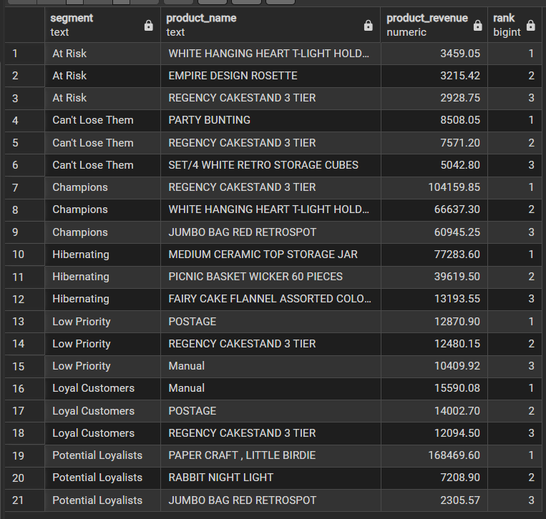
- Average Purchase Gap per Segment – Measured the average number of days between consecutive purchases.

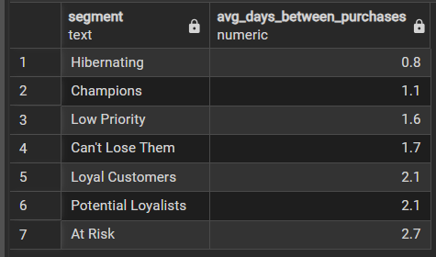

- Monthly Revenue Trend (Dec 2010 – Dec 2011) – Confirmed a strong Q4 seasonal spike, suggesting some customers classified as churned may be seasonal rather than permanently lost.

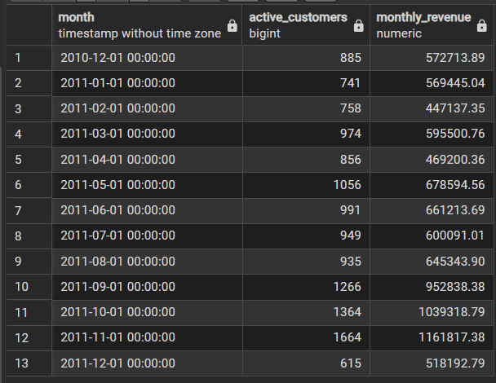

- Dashboard in Power BI

An interactive two-page dashboard was built in Power BI:

- Page 1 (Overview): Total revenue, customer count, active customers, revenue by segment and segment distribution.
- Page 2 (Churn & Risk): Revenue at risk, churn rate, segment-level risk metrics and a prioritised list of top 10 high-value churned customers.

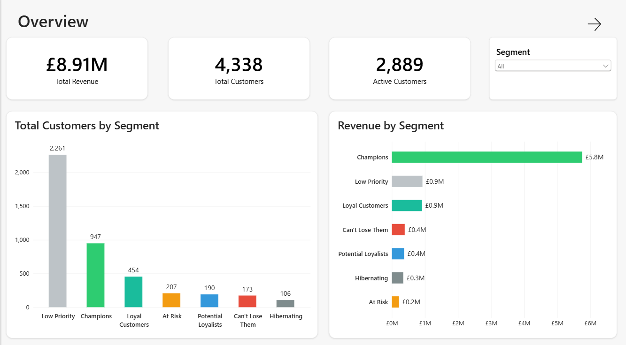

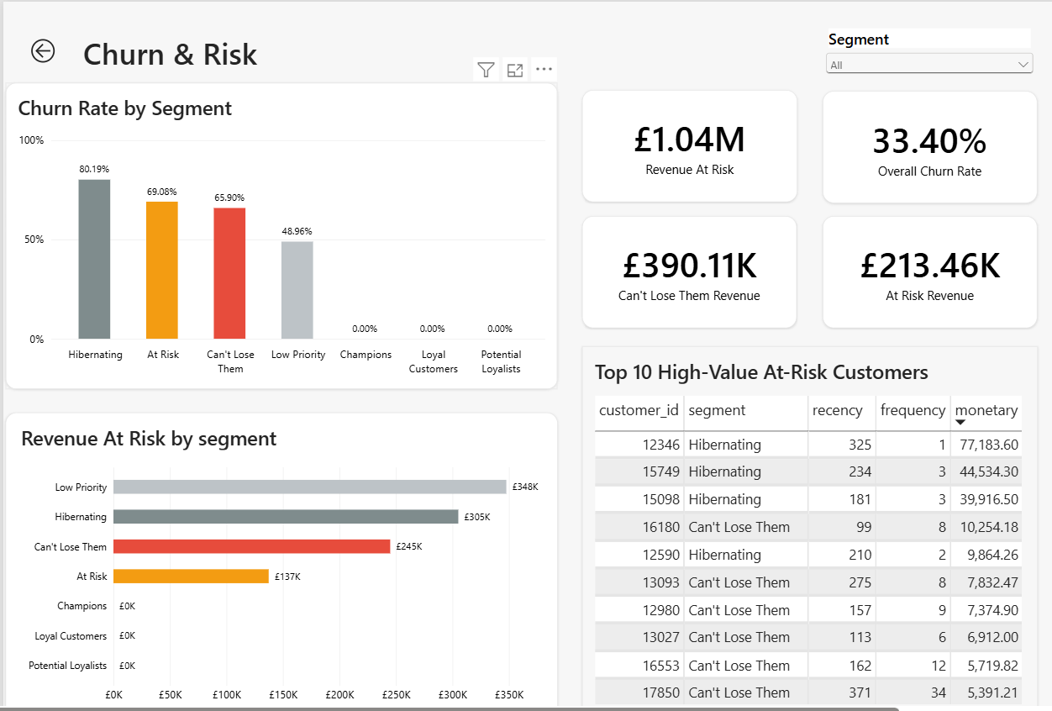
- Key Findings
- Champions + Loyal Customers (1,401 customers, 32.3%) generate 74.9% (£6.67M) of total revenue.
- £1,035,269 in revenue is at risk across all segments (customers inactive 90+ days).
- Can’t Lose Them is the highest-urgency win-back target. 173 customers, 93% churn rate, £398K already lost.
- At Risk is the most preventable churn. 207 customers, 68% churn rate, £241K at risk ,still within a recoverable window.
- 52.1% of customers are Low Priority (2,261 out of 4,338). Marketing spend should focus on the remaining 2,077 customers.
- Oct–Nov shows a seasonal spike (Black Friday / pre-Christmas). Some churned customers may be seasonal buyers. December is a partial month (data ends 9 Dec).

- Recommendations
 | Segment | Action
1 | Champions | Implement a loyalty tier program or offer early access to new products/sales to reward top customers
2 | Loyal Customers | Cross-sell complementary product categories based on past purchase behaviour to increase basket size
3 | Potential Loyalists | Create bundle offers or subscription incentives to increase purchase frequency and solidify their loyalty
4 | Can’t Lose Them | Launch a personalised win-back campaign with exclusive high-value offers or discounts to prevent churn
5 | At Risk | Automate a “we miss you” nudge at day 60 of inactivity, offering a small incentive to re-engage
6 | Hibernating | Send low-cost email campaigns with personalized high-value product recommendations or content relevant to their past interests
7 | Low-Priority | Supress these customers from high-cost marketing campaigns to optimize spend and focus resources on higher-value segments

- Limitations
- 90-day churn threshold is a business assumptions, not data-driven.
- No external factors (marketing spend, economic conditions) considered.
- Segment boundaries are rule-based, adjacent quintiles may produce similar profiles.
- Data covers only 12-month period; Oct–Nov spike may misclassify seasonal buyers as churned.

